Ain Shams University

Artificial Intelligence

Fourth Year Second Semester

September 2008

Answer all questions

Question 1:
- For the following term, give the output tree of the unification if it unify or else explain why unification would fail:
Unify ((parents X (father X) (mother sami)), (parents sami (father sami) Y))

- Given the following
- if it is cloudy and it is cold, then Aly is sad.
- it is cloudy if it is raining.
- it is raining.
- it is cold.
- is Aly sad?
Use resolution to show Aly is sad

Question 2:
Build a finite state acceptor and transition matrix that recognizes the following:
- All strings of characters from the alphabet {a,b,c,d} that contain the exact sequence “abc”.
- All strings of binary digits{0,1} that contain the exact sequence “111”.

Question 3:
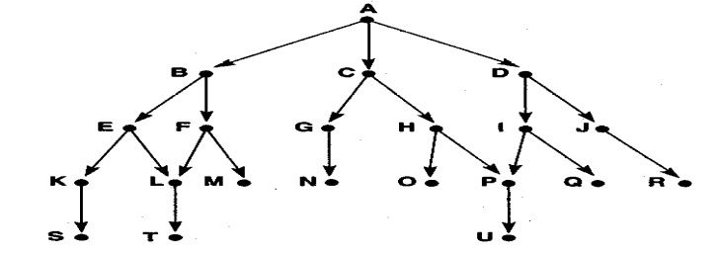
Write and trace the algorithms of Depth-first and Breadth-First search by using this graph.

Good Luck

